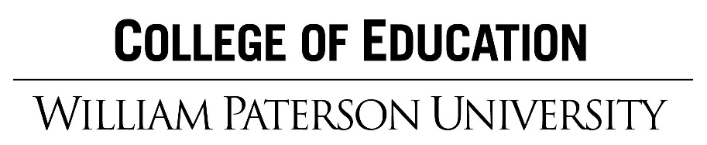

**Standards Based Framework**

**Mission Statement**

The College of Education at William Paterson University prepares teachers, leaders, and counselors and serves as a premier resource for diverse communities. Our nationally recognized and accredited programs meet the highest standards of professional preparation. The College creates educational opportunities through collaboration with local, national and global partners. We support student success and academic excellence through inquiry, scholarly work, critical reflection, and ongoing assessment.

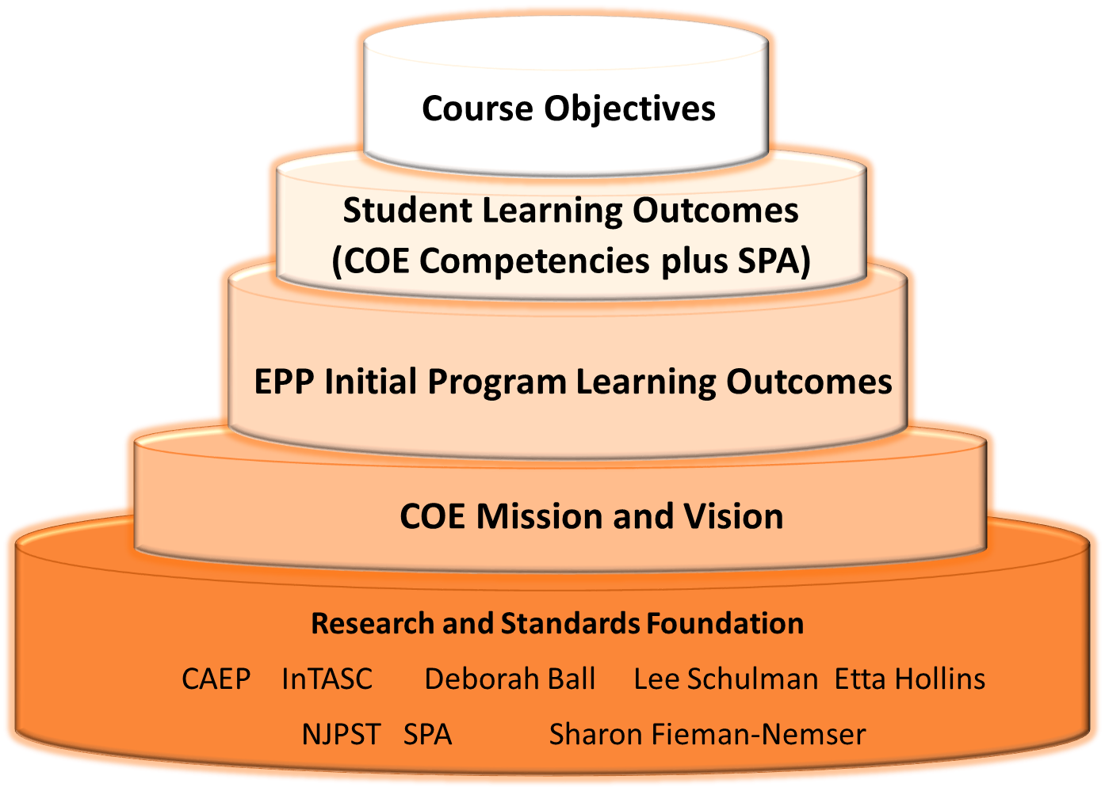

**COE Student Learning Outcomes and Objectives**

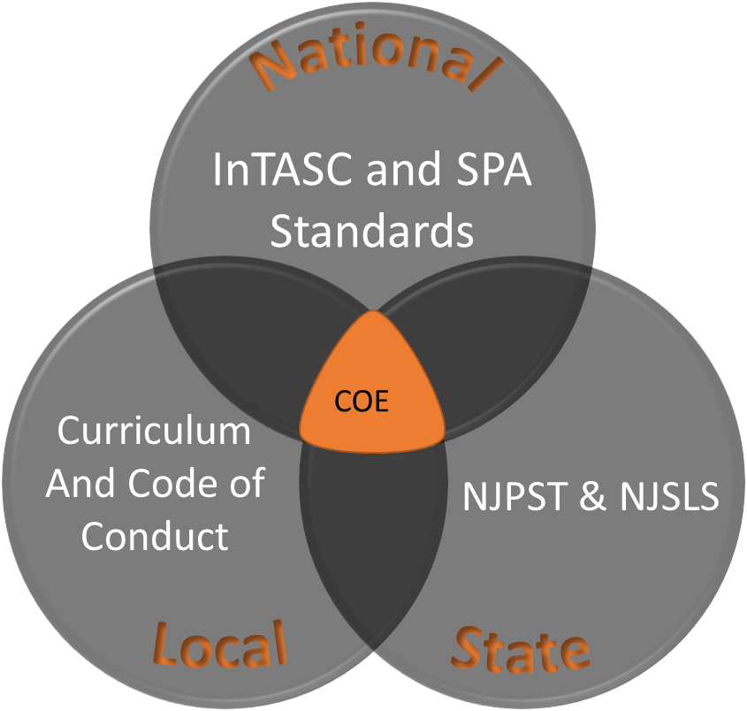

**COE Competencies + SPA**

